**Effects of Air Pollution on Forest Ecosystems**

**Bachelor of Technology**

By:

Group 2

Akash Sharma (2017327)

Anmol Singhal (2017332)

Raghav Rathi (2017083)

Rohan Rajpal (2017089)

Samarth Singhal (2017188)

Tejas Oberoi (2017367)



**ESC205A- Environmental Sciences**

**Indraprastha Institute of Information Technology, Delhi, New Delhi, India - 110020**

**(December, 2019)**

**Acknowledgements**

We’d like to thank our course instructor, Dr. Jitin Rahul, for providing us an opportunity to pursue this project at an undergraduate level course. Without his guidance, this project wouldn’t have been possible. We’d also like to thank the teaching assistants of the course for always helping us with our queries throughout the project.

**Abstract**

Around 31% (4 billion hectares) of the Earth’s surface is covered by forests, which is a major ecosystem sustaining millions of species of flora and fauna. The forest cover is declining due to human intervention and practices such as industrialization and urbanization, which results in deforestation. Such practices pose a significant threat to the forest ecosystem. Coupled with air pollution together makes it a deadly combination for the ecosystem. The rising concentration of pollutants in the air increases the exposure of forest cover to harmful gases like sulfur dioxide, ammonia, and ozone. In this report, we try to describe the effect of air pollution on the forest ecosystem and what changes it results in. We discuss the case studies of North America, Europe, and Australia and check the correlation between increasing levels of pollution with features such depth of root systems, etc. We also discuss the forest monitoring techniques and the challenges needed to overcome for accurate observations of the forest health data and its implications for future studies.

**Table of Content**

**List of Tables**v

List of Figures vi

**Chapter 1: Introduction**1

1.1 Introduction 1

1.2 Literature Survey 2

**Chapter 2: Air Pollution Trends**4

2.1 Ozone 4

2.2 Acidic Precipitation and Acidification of the Atmosphere 5

2.3 Ammonia 6

2.4 Heavy Metal 7

**Chapter 3: Forest Health Conditions**9

3.1 Air Pollution and Forest Fires 9

3.2 Air Pollution and Climate Change 10

**Chapter 4: Detection and Monitoring**11

**Chapter 5: Mechanisms of Action and Indicator Development**12

**Chapter 6: Soil and Nutrient Cycling**13

**Chapter 7: Genetic Aspects**15

**Chapter 8: Regional Trends**16

8.1 North America 16

8.1.1 Pollutant fumigation (Experimental): Aspen FACE 18

**Chapter 9: Conclusion and Future Work**20

**Appendix**20

**References**21

# 

# List of Tables

Table 1: Representation of biomagnification of mercury in an aquatic food chain.

Table 2: Emerging Research Issues at the 22nd Meeting for Specialists in Air Pollution Effects on Forest Ecosystems

# List of Figures

Fig 1: Amazon Rainforest Fire

Fig 2: Northeastern Hardwood Forests

Fig 3: Time Series of Ozone Emissions (ppb values)

Fig 4: Time Series of Sulphur and Nitrogen Oxides emissions (in million short tons)

Fig 5: Time Series of acidity of precipitation (measured in terms of Hydrogen ions micro-eq/L)

Fig 6: Time Series of Ammonia Emission for the Case study of Germany Livestock Farm and the neighbouring forest cover

Fig 7: Representation of geoaccumulation of Palladium in the surface soil of Forest Cover in the European Continent

Fig 8: Species *Lepidoptera* and Effect of Ozone on Plant Growth

Fig 9: Growth trends of trembling aspen upon exposure to increased levels of CO2 and O3.

Fig 10: The impact of increased CO2 and O3 levels on forest tent caterpillar performance

# Chapter 1: Introduction

## 1.1 Introduction

Forests, covering 31% of the land, form a flourishing ecosystem, giving food and shelter to the numerous species of plants, animals, and insects. They are a rich source of natural resources like wood, timber, etc. Lots of people, including tribals, depend on forests for their livelihoods. The forest ecosystem forms an integral part of the economy and plays various vital roles. Conservation of forests, therefore, should be the topmost priority for a nation. Unfortunately, human activities such as industrialization have led to a decline in forest cover. Deforestation to clear land for agriculture and commercial purposes is one of the primary reasons for declining forest cover throughout the world. This jeopardizes the forest ecosystem and disturbs the delicate balance present in the ecosystem.

Another substantial detrimental impact human activities have had on the environment is an increased level of air pollution in the atmosphere. Carbon emissions and green-house gases have resulted in rising global temperatures over the last century, which has led to significant climate change and global warming. The deleterious effects of air pollution are being felt by everyone, from humans in New Delhi to inhabitants of forest ecosystems. Air quality is degrading at an alarming rate, which is giving rise to a lot of health problems. Air pollution causes significant issues for not only biotic components of the ecosystem but also the abiotic components such as buildings and monuments.

In this report, we study the effect of air pollution on forest ecosystems. These problems - air pollution and decline in forest ecosystem - are almost always treated independently of each other even though there is a correlation between increased air pollution and decreasing forest health. We study these correlations and try to find to what extent does air pollution affects the forest cover and in what ways. We consider the major air pollutants such as ozone, nitrogen, sulfur, and ammonia and study the individual effect of these pollutants on various types of forest covers.

This study will help realize the detrimental effects of air pollution on forests and pave the way for better policies and preservation/conservation strategies in the future, keeping in mind this aspect of the problem.

## 1.2 Literature Survey

The focus has shifted to considering forests as a whole ecosystem while considering the effects of air pollution. Lovett et al. (2003) [1] studied the effects of air pollution on ecosystems of the eastern United States. They studied the impact on all the major ecosystems and forest ecosystems were one of them. Four air pollutants, namely sulfur, nitrogen, Ozone, and mercury, were considered in the study. In the regions of soil with acid-sensitive areas, soil acidification affected the function and composition of forests. Biogeochemical cycling was known to be affected by air pollution in general, but the exact effect and response of individual species weren’t known. Increased levels of Ozone also resulted in decreased efficiency of photosynthesis, which affected the plants, although higher mortality rates weren’t observed. Nitrogen levels present in the air were also found to affect the species composition of the forest ecosystem. It was recommended that air pollution should play a significant role in deciding conversation policies moving forward since it had so many effects on the forest ecosystem.

Bussotti et al. (1998) [2] studied the effect of air pollution in the forest ecosystems of Europe. Moving away from the focus on forests in northern Europe and central Europe, they studied forest decline, and the effect of air pollution had on the forests of southern Europe. The data available through the agencies, albeit being a little inconsistent, showed species fluctuation on a year-to-year basis instead of a direct decline in forest cover. The pollution and environmental changes were found to induce stressful situations for the ecosystem that led to deterioration. Conifer forests and mesophile forests of the Mediterranean were found to be the ones affected the most. The sensitivity of these forests to air pollutants was tested through several experiments. The effects of nitrogen and sulfur were found to very localized and less evident as compared to the impact of ozone levels. Foliar injuries were caused by Ozone in a lot of forest species. The direct relationship between air pollution and the areas impacted were largely left unknown owing to complex relationships between different elements.

Paoletti et. al (2010) [3] studied the holistic approach towards forest health and how it is affected by the pollutants in the air. Increased ozone levels, along with disturbing levels of carbon and nitrogen, were found to be the most significant factors affecting forest health.

All the above papers suggest a strong relationship between ozone levels in the air and the forest health with nitrogen, sulfur, carbon also having detrimental effects. In our paper, we’ll discuss this relationship further and more extensively.

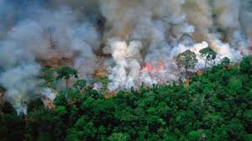

*Fig 1 :Amazon Rainforest Fire*

*Fig 2: Northeastern Hardwood Forests*

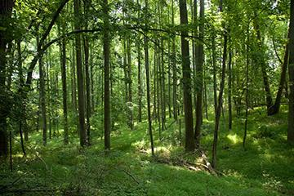

# Chapter 2: Air Pollution Trends

## 2.1 Ozone

O3 (at the surface level) is one of the prominent air pollutants which is formed through the oxidation of various other pollutants like NOx and other organic compounds. It is a serious air-pollutant which has adverse effects on plant metabolism and functioning. Although there have been no concrete methods to see the exact cycle of effects of ozone on the environment.

It has been seen how the ground-level ozone has been increasing at an incredibly high rate (ppb).

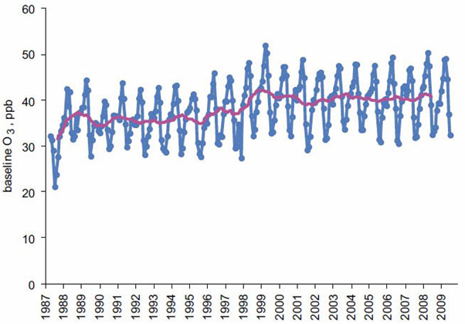

*Figure 3 : Time Series of Ozone emissions (ppb values)*

Many research papers have suggested that ozone have adverse effects on sensitive ecosystems and affecting the flora and fauna in it. Ozone is known to create hindrance in the photosynthesis process of the plants, reduces its growth and increases its susceptibility towards diseases, insect attacks as well as other air pollutants etc.

In addition to the effects on the flora, it will also have ill-effects on the ecosystems:

Loss of biodiversity is one of the consequences of ozone pollution (less -a variety of plants, animals etc). It changes to water and nutrient cycles due to ozone accumulation which further affects the quality of habitat.

## 2.2 Acidic Precipitation and Acidification of the Atmosphere

Acid rain (or acidic precipitation) arises from the oxidation of Sulfur oxides Sox and NOx Nitrates in the atmosphere leading to the formation of sulfuric and nitric acid which gets deposited on the forests in the form of rain, fog or cloud etc.

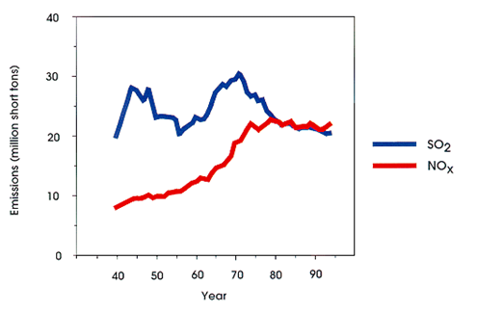

*Figure 4 : Time Series of Sulphur and Nitrogen Oxides emissions (in million short tons)*

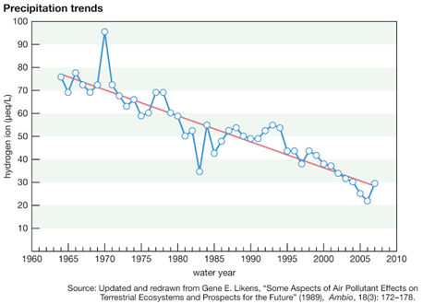

*Figure 5: Time Series of acidity of precipitation (measured in terms of Hydrogen ions micro-eq/L)*

The tremendous and consistent increase in the production of these oxides of sulfur and nitrogen leads to the formation of acid rain. This phenomenon of acid precipitation has led to further adversities in the environment around us (particularly forests). It has numerous ecological effects mainly on the aquatic environments. Acid precipitation damages the pH balance of the water bodies making them more acidic affecting aquatic and marine life. It also results in the aluminium absorption from the soil which often destroys the vegetation on the soil and is carried back to the lakes and streams as well. It further affects the forest flora by harming the leaves and needles of trees through damaging its waxy coating. It also causes havoc for the wildlife living in the forests by making them prone towards skin diseases and other respiratory problems.

## 2.3 Ammonia

Ammonia is considered as a reduced form of anthropogenic nitrogen emitted. The increase in ammonia emissions mainly from agriculture (manures, fertilisers etc.) In modernized nations, ammonia emissions come from extensive cattle farming and livestock rearing. (like pigs, cows etc). The graph below shows the case study of time series analysis of ammonia emissions due to extensive pig farming in Germany.

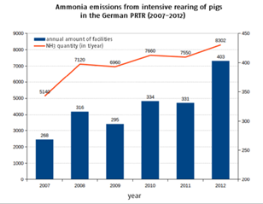

*Figure 6: Time Series of Ammonia Emission for the Case study of Germany Livestock Farm and the neighbouring forest cover*

These levels of ammonia emissions have toxic effects on the vegetation cover of the forests. It also leads to N accumulation stressing the balance of elements in nature. One of the most affected is the mosses and lichen which are very sensitive to the concentration of ammonia in the atmosphere.

This is also seen in many research papers which claim the absence of lichen in the ammonia-rich environment indicating the toxification by the ammonia on the bark of the acidic trees. This is due to the neutralizing effect of the ammonia on this acidic bark’s pH.

## 2.4 Heavy Metal

Heavy Metals including Palladium, Lead and Mercury etc are considered as one of the most dangerous substances (pollutants) in the atmosphere. Although, their respective concentration mostly less than the other pollutants mentioned above. The accumulation of these heavy metals in forests, however, can lead to much more dangerous consequences in the forests.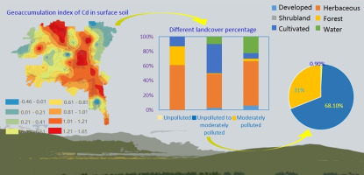

*Figure 7: Representation of geoaccumulation of Palladium in the surface soil of Forest Cover in the European Continent.*

The worst of which is the phenomena known as biomagnification indicating the accumulation of these pollutants in every organism belonging to the food chain creating havoc all around the forest ecosystem.

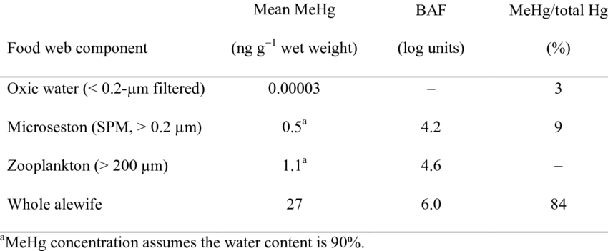

*Table 1: Representation of biomagnification of mercury in an aquatic food chain.*

# Chapter 3: Forest Health Conditions

## 3.1 Air Pollution and Forest Fires

With a change in land usage and an increase of activities like slash and burn, fires are repeatedly causing harm to the forest ecosystem. These fires have led to an increase in air pollution, extended fires, depletion of the forest, and extinction of species. Paoletti, E., et al.

Recently the 2019 Amazon rainforest fires have caught attention around the world. It is estimated that the fire cleared over 906 hectares of forest land in 2019(Wikipedia). Slash and burn activities, and political stunts have worsened the rainforest fires over the years. Very high levels of N and O3 deposition have increased leaf turnover rates. In addition to this, lignin and N content has risen.

|  |  |
| --- | --- |
| **Risks** | **Hurdles** |
| Air pollution | * Competition among plants on the responses to stressors * How the availability of nutrients hold long-term carbon absorption by plants * How air pollution affects the water ecosystem * How air pollution affects the soil ecosystem |
| Elevated CO2 | * Using experiments at very long durations to utilize CO2 and O3 free systems * Understanding how changing climate and increased pollution effects limit the absorption of CO2 by forests”Paoletti, E., et al.” |
| O3 | * Studying the biological effects of O3 on stomata * Make O3 standards more sustainable |
| Interactions | * Analyze the drought effects of air pollution and climate change * Understanding effects on reproductivity and plant phenology |
| N | * Exploring more concepts in nitrogen saturation * Check the effects of multiple factors on environmental stress |

*Table 2: Emerging Research Issues at the 22nd Meeting for Specialists in Air Pollution Effects on Forest Ecosystems*

It is of an urgent need to build predictive models to analyze the future impact of such fires on the environment around us. The effect of forest fires in terms of carbon emissions has to be calculated.

## 3.2 Air Pollution and Climate Change

The significant studies of pollution on forest check the effects on plants and trees. This topic aims to study a much broader spectrum as pollution has effects on the whole ecosystem. Studying the ecology effects will give a much better picture of how air contamination is impacting forests. The impact on soil, water, and between organisms is equally important to study. The above factors together constitute the health of the ecosystem of the woods. The impacts of the major pollutants have been discussed.

However, there are more emerging pollutants that might pose threats similar to O3 very soon. These pollutants are secondary organic aerosols, or simply SOAs. They are produced by oxidation of multiple generations of a parent organic molecule.

A lot of products and techniques can be used to measure air pollutants. Cuvettes made up of leaves, greenhouses, chambers of climate, or open top. Sap flow measurements can help calculate the total plant ozone uptake”Paoletti, E., et al.” A lot of time and effort has been invested in moving away from theoretical and more towards field studies to get a better perspective on plant health.

It was realized that the effects of pollution on plants depend on abiotic factors along with pollution and insects. This reveals that smaller-scale interactions in the forest might have a higher impact than the little ones. Further analysis reveals that pathogen pollution is less robust to climate than to the pollutant themselves. New theories such as GDBT or Growth Differentiation Balance Theory gives a measure to test the differences between defense-related and growth-related metabolism ”Paoletti, E., et al.” Growth-related metabolism addresses high resource ability, and defense-related is low resource ability.

# Chapter 4: Detection and Monitoring

The monitoring of forests is essential to record existing forest health status and improvements. The monitoring techniques should be designed appropriately in a way that it defines clear objectives and avoids ambiguity. Two essential ways of monitoring are to measure the changes in plant phenology due to climate changes and the forest’s aggressive response towards pollution.

At the level of monitoring, species-rich plant populations have been shown to suffer more impacts of contamination disruption due to pollution relative to species in scarce communities. This finding challenges the widely accepted hypothesis of enhanced resilience in species-rich ecosystems and adds to the analysis of the relationships between diversity and stability.

O3 is the most major pollutant that has concerned scientists, and hence extensive monitoring and studies are being conducted regarding this issue at the international level.

Under low concentrations of O3, the peak of O3 tended to have more significant effects on tree defoliation. These techniques of monitoring were although efficient in the short run. In the long-run future monitoring, designs shall consider the role of the environment and the relationship between stressor and indicator within the context of an adequate statistical model.

# Chapter 5: Mechanisms of Action and Indicator Development

Action mechanisms and pollution stress indicators continue to be areas of significant contributions to research into air pollution. Identifying common or unique markers of individual stresses is especially challenging. Most biochemical markers are not novel to contaminants, making it challenging to distinguish causative agents with a combination of pollutants in the atmosphere.

At the start of the monitoring program, the impact of air pollution on forests was mostly defined in terms of tree defoliation, based on the reports of extreme defoliation occurring at locations for which severe effects of air pollution are recorded. Hence, defoliation was adopted as a good indicator. Defoliation could actually be considered as an indicator of the overall condition of the tree in this respect. But, it should not be considered a gauge for measuring the effects of air pollution of forests as it does not take many exogenous factors into account.

After analyzing the shortcomings of defoliation as an indicator, specific microscopic techniques were widely used to diagnose O3 and other stresses such as heavy metals, irrespective of the site, and environment. The pervasive use of stable isotope technology in research on air pollution has enhanced our knowledge of the physiological effects of pollutant stress and has, in some cases, been shown to detect pollutant sources.

Another way to model the indicator is by using the stomatal behavior of the leaves of the trees. While measuring exposure to O3, most models and exposure estimates include only daylight hours. The results for the longer term were although found to be sluggish.

# Chapter 6: Soil and Nutrient Cycling

The idea of understanding soil composition and recent trends regarding it is essential for the health of forest ecosystems, especially the tropical forests like the Amazon. Most of the rainforest soils are devoid of important nutrients including phosphorus, calcium, potassium and magnesium. This can be attributed to the fact that there has hardly been any volcanic activity in these regions that acts as a major boost for introducing new nutrients and replenishing the existing ones in the forest soils. However, despite this lack of fertility, the key feature that makes most tropical forests significantly rich in vegetation and biodiversity is because of nutrient cycling.

Nutrient cycling in rainforests occurs mainly due to nutrients like carbon, nitrogen and other inorganic compounds being locked up in the living or the dead matter occurring in abundance. As this organic matter decays, it gets recycled soon and makes some nutrients reach the soil, enabling it to become sterile and rich again. The instant and efficient decay of perishable content occur because of decomposers like bacteria and fungi that make an integral part of the forest ecosystem.

Paoletti et. al (2007) brings out certain important aspects regarding nutrient cycling in forests that need suitable consideration. These include the critical levels of Nitrogen in the forest soils and Nitrogen saturation. Saturation of N in the soil can be referred to as the net retention of N in forest ecosystems. However, the paper brings out the fact that this may not represent N saturation in its true sense. A research done by the Fernow Experiment Forest in West Virginia focuses on how Nitrogen saturation might not always be a consequence of its retention in the soil. This paper also makes it evident that several factors play a role in determining the critical N load of a particular forested region, which include the level of pollutants, susceptibility to drought, presence of insects and the standing age of the forest. This suggests the importance of including multiple stresses while evaluating the critical N load of a region.

There are interesting insights obtained regarding soil composition statistics. A revelation made is that coarse-grained soils found near areas prone to drought result in increased plant growth, as a result of soil compaction, which happens due to the rise in the water holding capacity of such soils. This shows us the phenomenon of soil compaction in a new light, as prior to this, it was mainly considered to have negative effects.

Another key insight from the paper is the discussion about ‘hot spots’ or ‘hot moments, which are microsites present in soils where there is a possibility of high nutrition content. Harnessing information about these rich sites present in the soil is imperative for a deep understanding of soil structures in forests and what ecosystem changes in the soil mean for the flora and fauna of forests is the goal of future researchers.

# Chapter 7: Genetic Aspects

Paolleti et. al (2007) [4] also discussed the genetic factors that could be affected due to air pollution and climate change in forest ecosystems. Researchers are trying to gauge reactions of several DNA sequences of trees to various environmental stresses and are looking forward to delving into the analysis of how alterations in physiological traits are affecting specific chromosomes of several species. Some noteworthy mentions include the studies carried out to gauge the impact of environmental changes on gene regulation with regards to DNA methylation.

Air pollution results in a steep increase in the levels of ozone and carbon dioxide in the air. A key aspect that the paper talks about is to examine the reproductive fitness levels of trees which are exposed to such critical levels of these greenhouse gases for a significant portion of their lives. Research done in this domain aims to analyse the role of community dynamics in dealing with how forest ecosystems are being affected genetically as a result of the alarming increase in levels of gases like ozone and CO2.

# Chapter 8: Regional Trends

## 8.1 North America

In previous works, McLaughlin and Percy (1999) [6] performed an analysis of the top four North American air pollution-related forest case studies ranked by prominence in a retrospective manner. Their investigation led them to the conclusion that ozone and/or nitrogen deposition (single or in the form of co-exposure) caused changes in pool dimensions and provision patterns of carbon, in-stream rates of Nitrogen, brought about modifications in penetration and energy of root arrangements in addition to changes in rates of supply of calcium. These changes indicated paradigm shifts in the functions about ecology happening currently in varied forest types spanning large areas in North America.

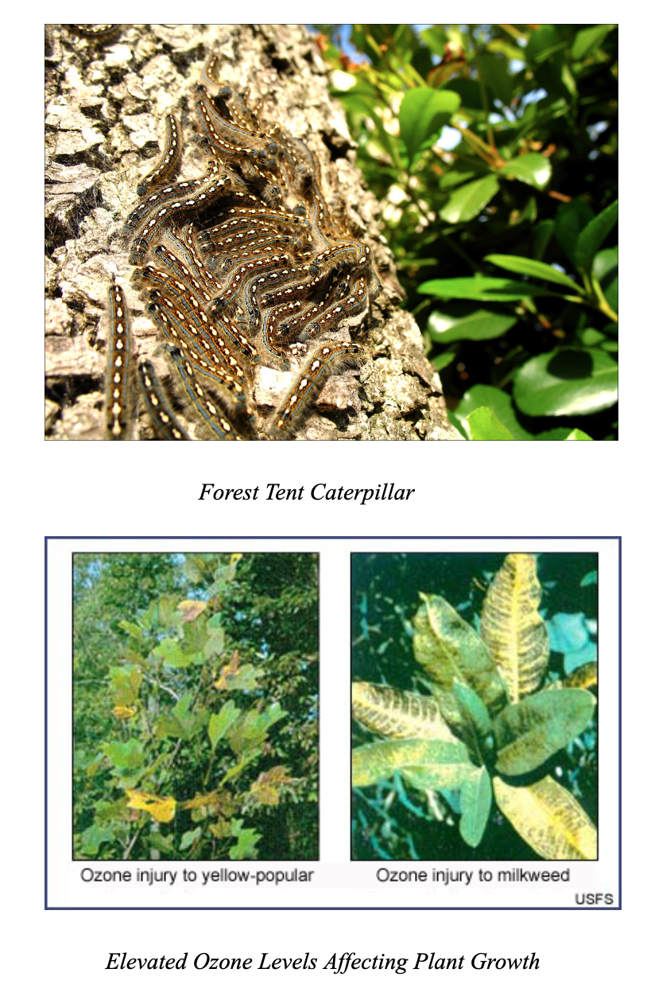

*Fig 8: Species Lepidoptera and Effect on Plant Growth*

They claimed that the impact of these harmful processes concerning future health of North American forests could get aggravated because of climate change. In a paper published by Chappelka and Samuelson (1998), investigations revealed that ozone causes foliar injury on numerous species of trees spanning across the majority of eastern US. Nevertheless, they could not confirm these observations as being direct effects of these processes as a number of factors could explain these effects.

In Sheffield and Cost(1987), A decline in the growth rates of flora was reported in the early 1980s in South-eastern Pine forests due to lack of management. Fox and Mickler (1996) provided summarized accounts of the research processes carried out through the Southern Commercial Forest Research Cooperative. They made a compilation of brief accounts of features of forests, results from numerous projects belonging to field and experimental domains coupled with stresses (biotic as well as abiotic). At ambient levels, examinations were conducted and delivered proof that decent concentration levels of ozone can increase water stress and stunt growth in trees of larger sizes. McLaughlin and Downing (1996) studied the effect of moderate levels of ozone on large trees by examining seasonal patterns of growth of mature loblolly pine (*Pinus taeda L.*) over five years. Techniques like Regression Analysis concluded marked impacts of ozone on growth patterns of stem despite significant variations in levels of ozone, temperature and rainfall. (McLaughlin and Downing, 1995). Exposure of ozone coupled with moisture content in soil and high temperatures of air resulted in a decrement in rates of at which stem-expansion occurs. The responses to ozone were rapid, displaying visible results within the first three days upon being exposed to ozone at concentration levels of 40 ppb. The studies claimed that ozone levels lead to retardation of growth of aged trees found in forests. Moreover, interactions with climate and ozone were declared as the probable causes for changes in south-eastern US forest trees growth rates in future.

Majority of the mixed coniferous forests in Southern California have been subjected to extreme levels of ozone and nitrogen, is the highest in North America since the middle of the 1950s. Recently, novel pieces of evidence have been discovered for the increase in the presence and impacts of these polluting entities in the Sierra Nevada region in South Western US. These reasons have been well documented in the volume (Bytnerowicz et al., 2003). (Miller and McBride, 1999) Performed investigations on the subjection of forests to high concentrations of ozone and oxidants in the San Bernardino Forest. They concluded it as a typical case of hierarchical forest response to Ozone. The high levels of Ozone caused various kinds of physical abnormalities in trees. The abnormalities comprised early needle loss, decreased the availability of nutrients, decrement in production of carbohydrates, decrease in vigour, increase in vulnerability to bark beetles and retarded diameter or height growth. Growth rates of Radial base area also saw a decline. High concentrations of nitric acid vapours (Bytnerowicz et al., 1999) and negative changes in development as a result of fire suppression are also probable contributing factors.

### **8.1.1 Pollutant fumigation (Experimental): Aspen FACE**

FACE is an abbreviation for The Aspen Free Air Carbon Dioxide Enrichment. It was an experiment conducted in Rhinelander, Wisconsin, USA and was the first open-air facility to study the effects of carbon dioxide and Ozone on forest trees. The experiment highlighted the negative impact of the increase in Carbon Dioxide and Ozone concentrations on ecological functions of forests and carbon and biogeochemical nitrogen cycles. Their effects were examined with regards to productivity and growth, physiological processes, sequestration of carbon, interactions occurring in a competitive manner, stand dynamics, connections with pests and ecosystem-processes, such as decomposition in the foliar department, weathering of minerals and cycling of nutrients. During the span of the first four years, the average ozone levels in the rings of fumigation were 46-55 pb.

(Karnosky et al., 2003) reported that increased levels of carbon dioxide (560 ppm) and Ozone have conflicting impacts. This has been consistent in the case of a number of functional groups viz. the expression of genetic material, foliar biochemistry and gas exchange occurring at the ecosystem level. It was observed that low concentrations of Ozone cancel out the positive impacts induced by Carbon Dioxide. In paper Percy et al. (2002), the experiments revealed that factors like physical and chemical leaf defences and productivity had marked effects on exposure to ozone and Carbon Dioxide. Ozone had a detrimental effect due to its property of stimulating prime defoliators like Forest Tent Caterpillars(Figures 1 and 2). These modifications in the quality of plants affected the populations of insects and diseases.

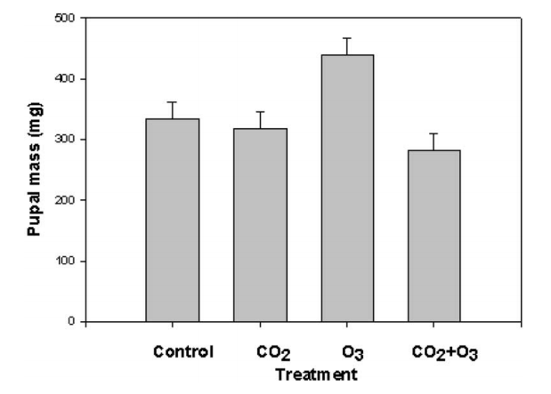

*Figure 10:* The impact of increased CO2 and O3 levels on forest tent caterpillar performance. Considerable increment in pupal mass due to changing plant  
quality due to O3 can be observed . (Reproduced from Percy et al., 2002.)

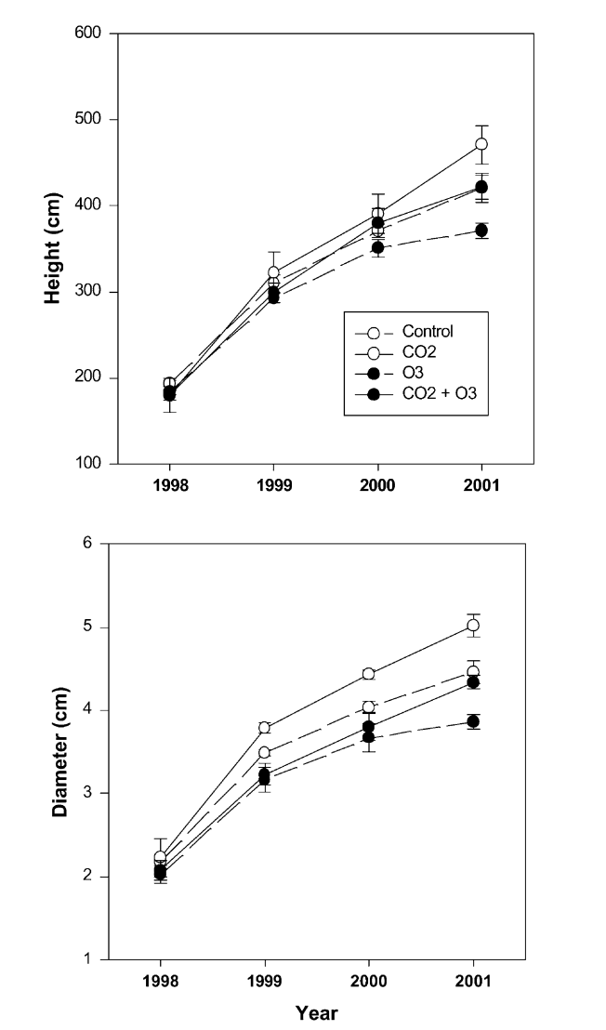

*Figure 9:* Growth trends of trembling aspen upon exposure to increased levels of CO2 and O3. Data are basis of means 1 SE, positive and negative, averaged over five clones covering a range of sensitivities to O3. Considerable decay in height and diameter due to O3 over a period of time and the ability of O3 to counter-balance gains due to raised CO2 should be noted .(Reproduced from Percy et al., 2002.)

# Chapter 9: Conclusion and Future Work

Tackling air pollution and its catastrophic effects on our environment has become the need of the hour. These impending problems are not only limited to the scope of metro cities and urbanized localities but have created havoc all across the globe, significantly affecting every ecosystem sustaining life on this planet. Forest ecosystems are essential for survival and constitute the most important and diverse component of the biosphere. Understanding the implications of ever-increasing air pollution and the alarming rate at which the climate is changing is imperative to ensure the health of the ecosystem and thus, the continued existence of life on Earth.

This paper attempts to address this problem by doing a comparative analysis of research being carried out in several domains to study how forest ecosystems are evolving with respect to the current environmental problems, and whether we as crusaders of protecting the environment can play a role to address the issue. Our main focus remains on analysing the case studies of North America, Europe and Australia. We also briefly discuss tropical forest ecosystems, including the Amazon rainforests, based on several important factors. We try to correlate aspects like depth of root systems, nutrient cycling, soil composition and genetic information of species with the increasing levels of air pollution and the drastic changes in climate. We also discuss forest monitoring techniques to aid forest ecosystems to adapt to these sudden changes.

We propose the need for future research in this domain, especially to understand how forest ecosystems respond to various stresses laid upon them as the air pollution trends and climatic characteristics continue to change drastically. The need for experimentation to study the impact on several features of forests introducing them to constant stress is talked about. Various other research needs pertaining to the physical, chemical and biological composition of forests and how they are being affected are discussed.

Since the problem has an immense scope of further research and is of massive importance in these times, policymakers need to invest and support such research activities and try to bring sufficient awareness regarding them. This is essential so that these limited efforts being made to address the issue at hand become a global collective effort and yield benefits for the entire planet.

# Appendix

Biomagnification and Bioaccumulation

Bioaccumulation (Biomagnification ) is defined as the increment in the contaminant concentrations in the living organisms. Few of the characteristics of this phenomena are:

Bioaccumulation in organisms will enhance the existence of industrial and hazardous chemicals in the ecosystem as a whole, since they can be fixed in the tissues of living organisms.

# References

[1] Lovett, Gary M., Timothy H. Tear, David C. Evers, Stuart E. G. Findlay, B. Jack Cosby, Judy K. Dunscomb, Charles T. Driscoll, and Kathleen C. Weathers. “Effects of Air Pollution on Ecosystems and Biological Diversity in the Eastern United States.” *Annals of the New York Academy of Sciences* 1162 (April 2009): 99–135.<https://doi.org/10.1111/j.1749-6632.2009.04153.x>.

[2]Bussotti, F., and M. Ferretti. “Air Pollution, Forest Condition and Forest Decline in Southern Europe: An Overview.” *Environmental Pollution (Barking, Essex: 1987)* 101, no. 1 (1998): 49–65.<https://doi.org/10.1016/s0269-7491(98)00039-6>.

[3]Paoletti, E., M. Schaub, R. Matyssek, G. Wieser, A. Augustaitis, A. M. Bastrup-Birk, A. Bytnerowicz, M. S. Günthardt-Goerg, G. Müller-Starck, and Y. Serengil. “Advances of Air Pollution Science: From Forest Decline to Multiple-Stress Effects on Forest Ecosystem Services.” *Environmental Pollution (Barking, Essex: 1987)* 158, no. 6 (June 2010): 1986–89.<https://doi.org/10.1016/j.envpol.2009.11.023>.

[4] Paoletti, E., Bytnerowicz, A., Andersen, H. E., Ferretti, M., Grulke, N., Günthardt-Goergb, M. S., ... & Matyssek, R. (2007). Impacts of Air Pollution and Climate Change on Forest Ecosystems—Emerging Research Needs [E. Paoletti, A. Bytnerowicz, Ch. Andersen, A. Augustaitis, M. Ferretti, N. Grulke, MS Günthardt-Goerg, J. Innes, D. Johnson, D. Karnosky, J. Luangjame, R. Matyssek, S. McNulty, G. Müller-Starck, R. Musselman, K. Percy]. The Scientific World Journal., 2007, Vol. 7.

[5] Percy, K. E., & Ferretti, M. (2004). Air pollution and forest health: toward new monitoring concepts. Environmental pollution, 130(1), 113-126.

[6] McLaughlin, S., and K. Percy. “Forest Health in North America: Some Perspectives on Actual and Potential Roles of Climate and Air Pollution.” *Water, Air, and Soil Pollution 116: 151-197, 1999.*, 1999.<https://www.fs.usda.gov/treesearch/pubs/2101>.